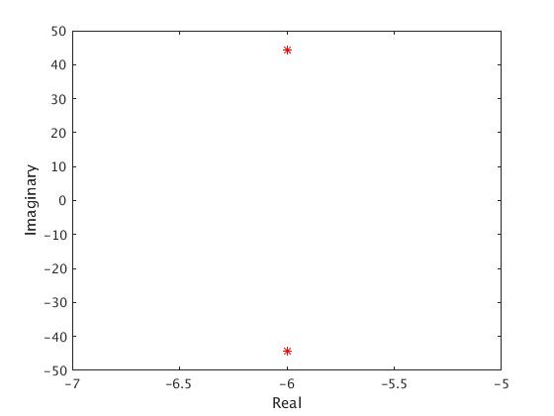

Figure 3 Q3b roots of closed-loop system

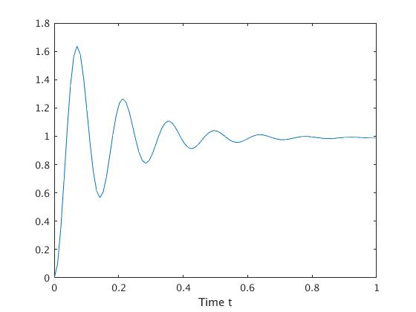

Figure 4 Q3b time response of the output for a step reference input with K=9.9

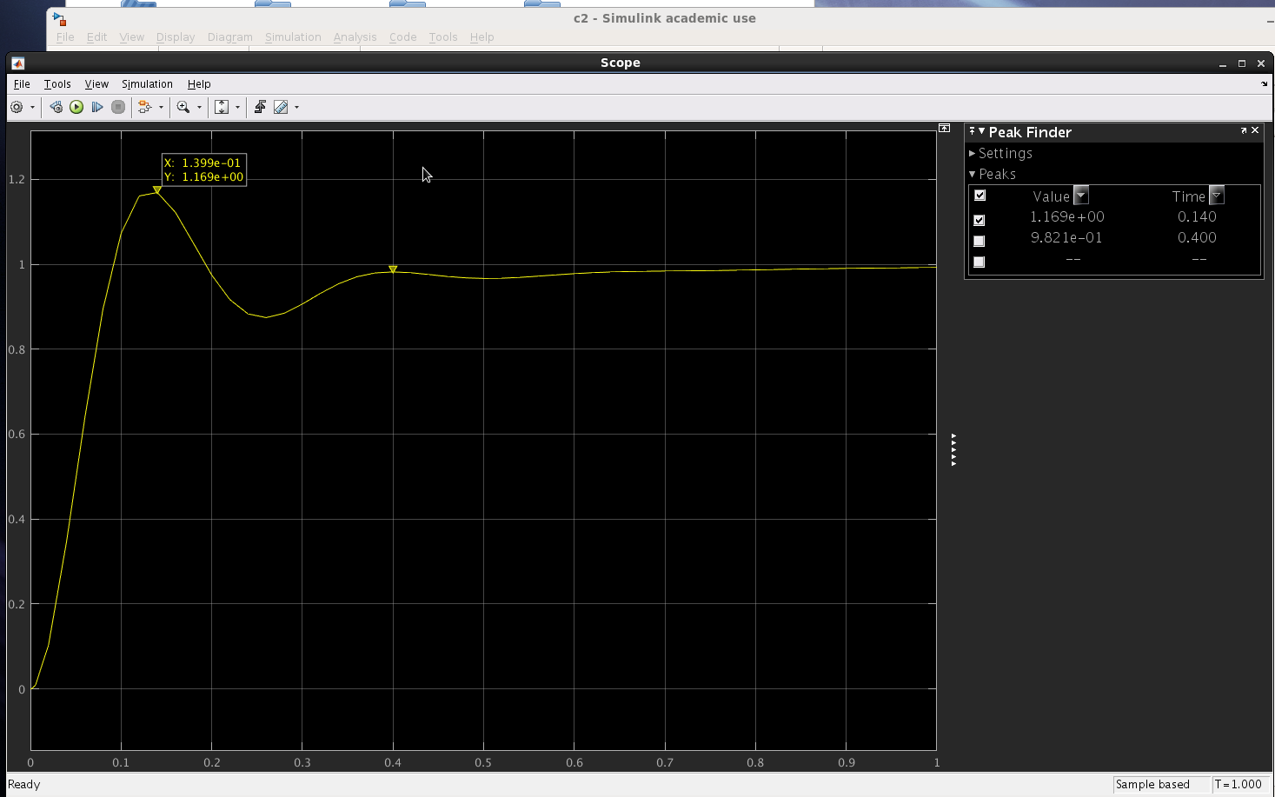

Figure 1 Q2c find K_1

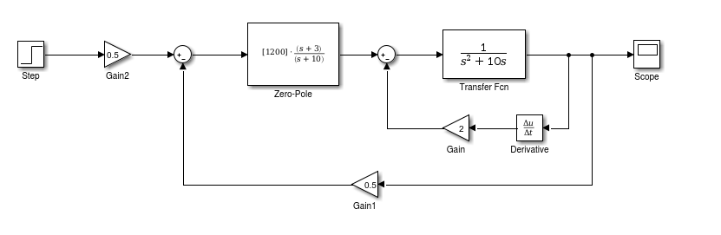

Figure 2 Q2c simulink model for finding K_1

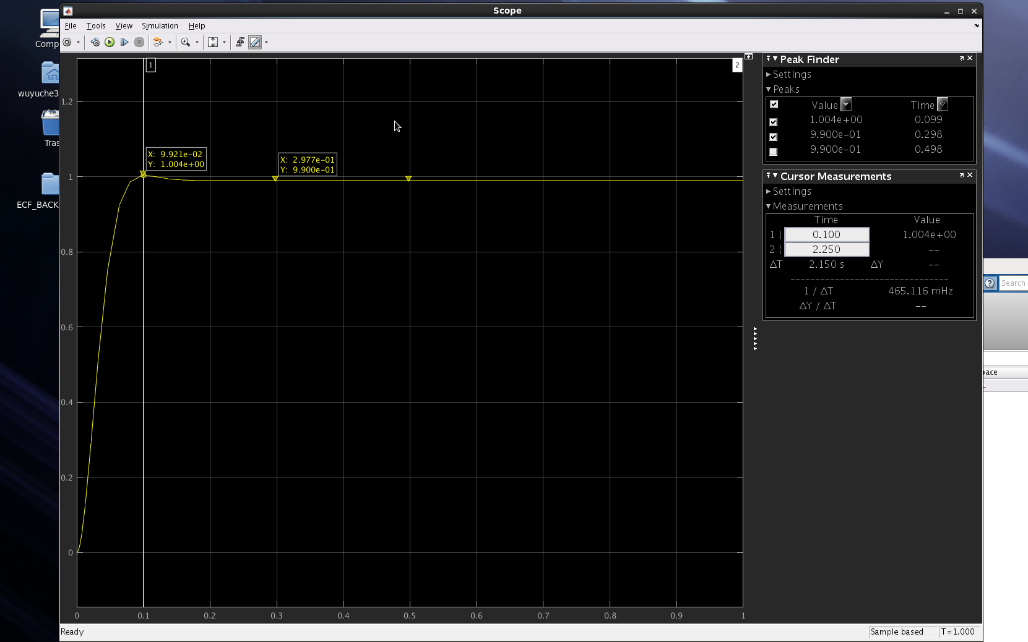

Figure 5 Q3d find values of kd and kp

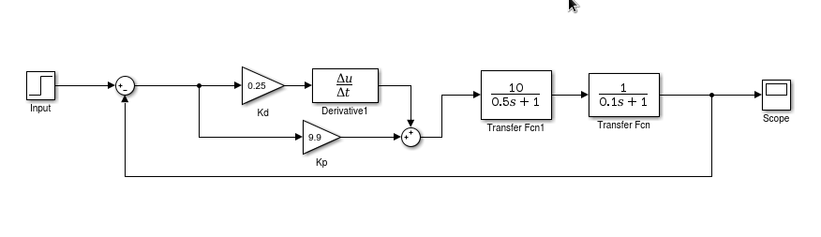

Figure 6 Q3d Simulink model for finding kd and kp